WINDOWS ADMINISTRATION(Hariharan)

promocode- Q0WXEWG424TX8QYNX0

outlook.live.com

www.skillpipe.com

portal.azure.com

download the windows 10 iso from evalution for client vm and windows server 2016 iso from evaluavation for server vm

we need to create client(4gb),server(4gb) vm and server core(2gb) vm

In server core vm,

tools needed to download for configruing NANO server

 1. download nano server image builder

2. download  windows 10 ADKsetup

3. download  windows 10 ADK WINPE  setup

servercore command is sconfig

to connect each VM we need to create a virtual switch that is in virtual switch manager>internal.

apply all VM to connect in virtual switch. In settings>network adapter>internal.

configure ip address for 2016 desktop vm

1. login as administrator

2. server manager -- local server --- select ethernet ---select properties

3. uncheck ipv6 and select ipv4 and select properties

4. select use the following ip address 192.168.1.1

5. subnet mask type 255.255.255.0

6. click ok

7. click computer name click change

8. delete computer name retype computername server

9. restart your vm

to ipconfig,

servercore vm>sconfig>network adapter >select change adapter address>static ip>192.168.1.2>restart.

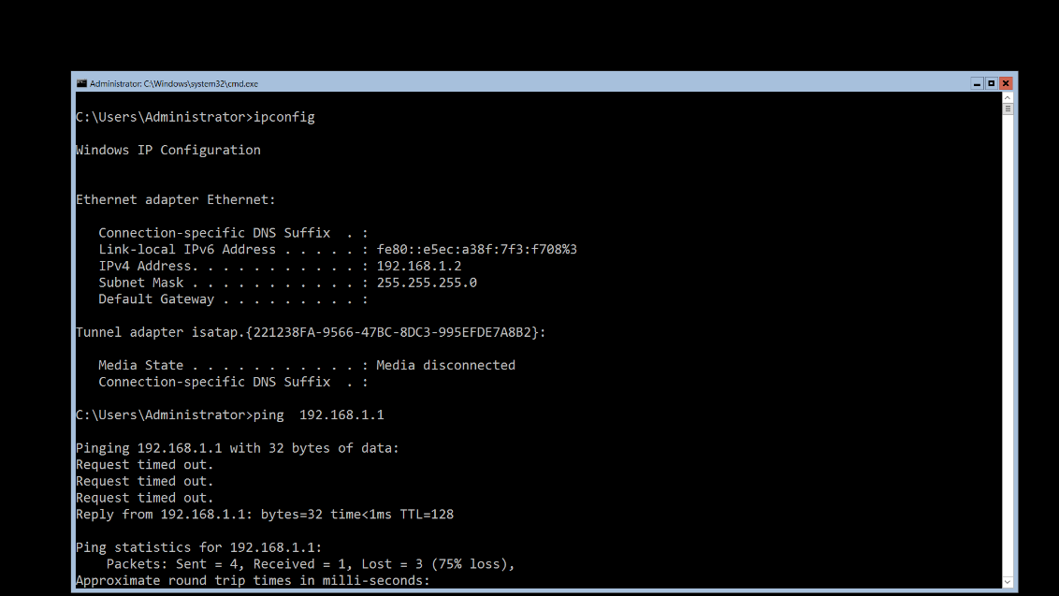

to check ip config,

servercore vm>ipconfig.

to ping GUI(2016) vm and server core vm, 1st we need to turn off the firewall in GUI(2016)- localserver>firewall.

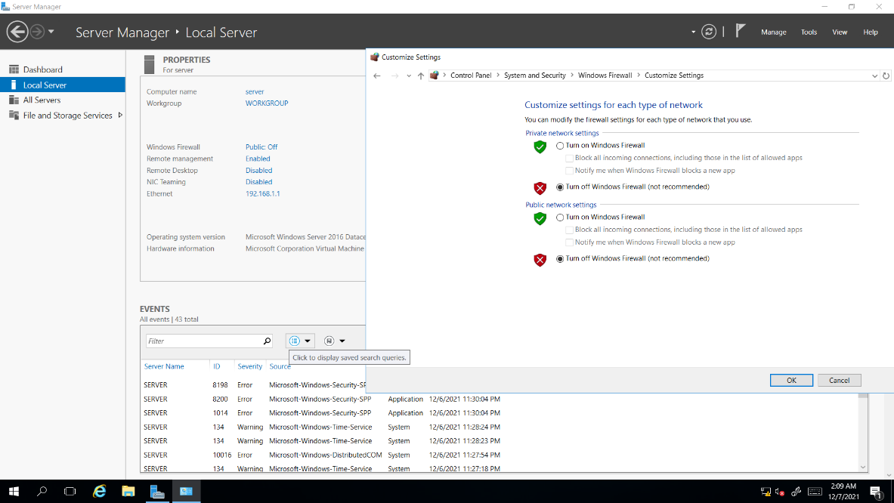

Commands – Powershell,

set-NetFirewallProfile -Profile domain,public,private -Enabled False

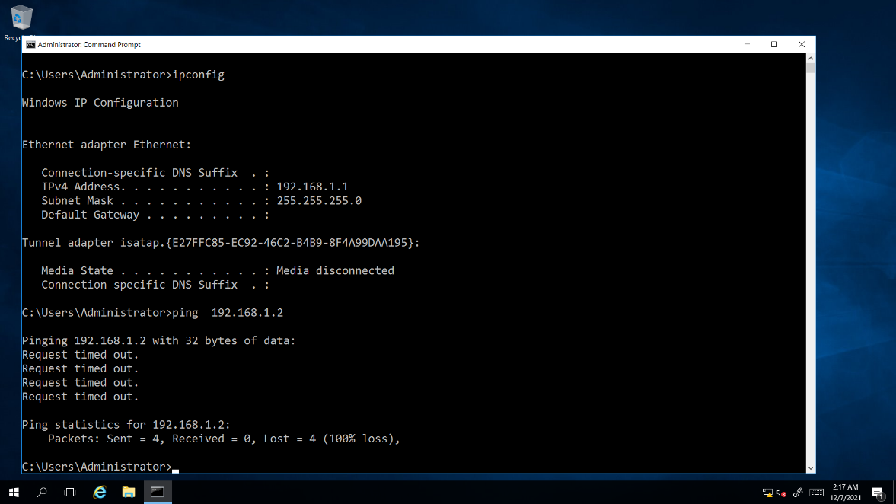

turnoff firewall in servercore

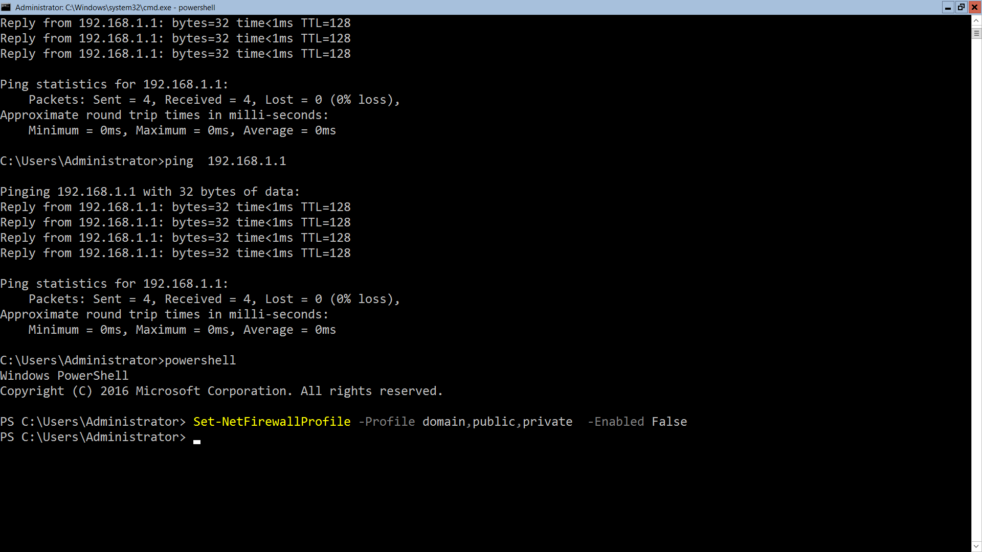

how to do remote management of server core using GUI vm

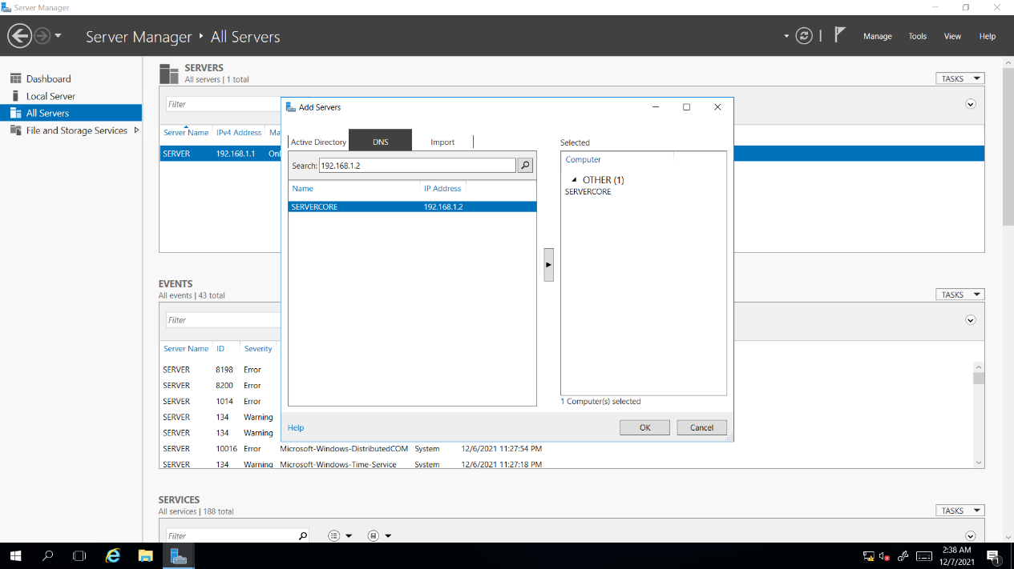

how to enable remote desktop in server core using sconfig  command

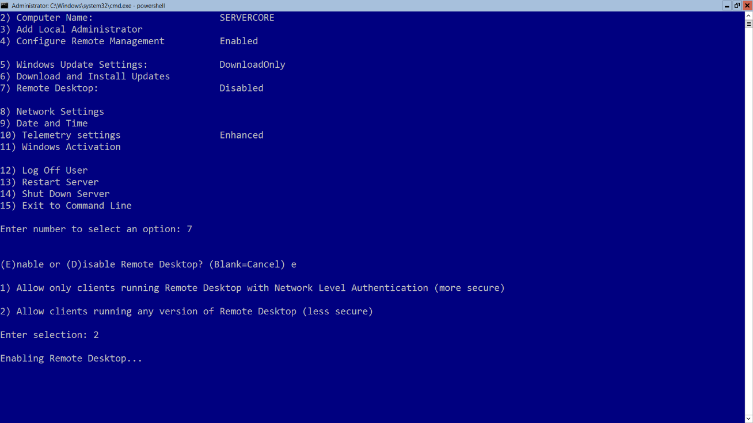

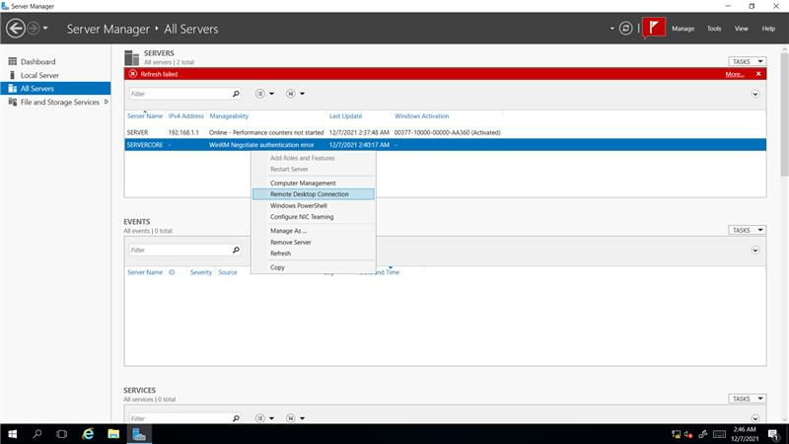

To create a virtual hard disk ,

New>harddisk>vhd>dynamically disk>5gb.

how to attach virtualhard disk in vm

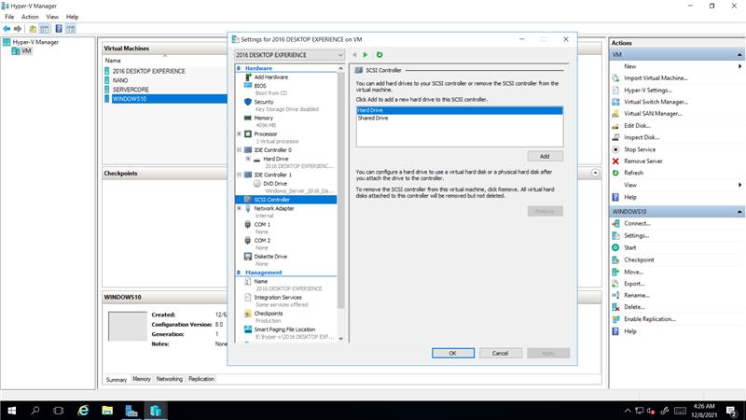

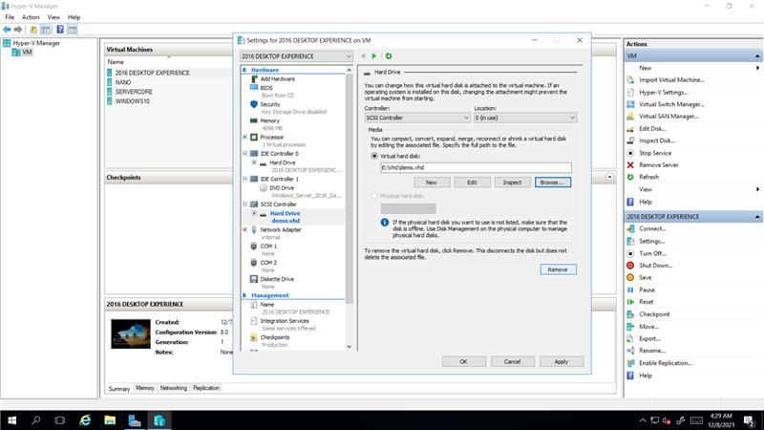

Thn we need to format a demo vhd,

In GUIVM>servicemanager>computrmanagement>diskmanagement>select demo vhd make online and intiliase>and file type is refs>format.

Then convert basic to dynamic.

* convert dynamic disk in to basic disk using  diskpart commands in command prompt  
    
  1. diskpart.exe  
  2. list disk  
  3. select disk 1  
  4. clean  
  5. create partition primary  
  6. format  fs=NTFS  quick  
  7. assign letter =E  
  8. active

configuring  stroage  pool in windows server  2016

1. create 3 vhd name it as  disk2,disk3,disk4(vhd,dynamically expanding  size 5gb )

 2. go to settings  attach 3 vhd one by one

1.creating  parent  vhd

 2. mount  parent  vhd  store some data and detach parent vhd

 3. creating  differencing vhd(child) using parent  vhd

 4. mount  child  vhd it contains  parent  data

Powershell

Command,

1 get-help \*vhd\*  
2 Get-Help New-VHD -Examples  
3 Get-Help New-VHD -ShowWindow  
4 Get-Help New-VHD -Full  
5 New-VHD -Path E:\vhd\demo1.vhd  -SizeBytes 10gb -Dynamic  
6 New-VHD -Path E:\vhd\demo2.vhdx  -SizeBytes 10gb -Dynamic

convert vhd in to vhdx using powershell

 get-help \*vhd\*  
 Get-Help Convert-VHD -Examples  
 Convert-VHD -Path E:\vhd\demo1.vhd -DestinationPath C:\NANO\demo1.vhdx  
 Convert-VHD -Path E:\vhd\demo2.vhdx -DestinationPath C:\NANO\demo2.vhd